03

Guidance in Love

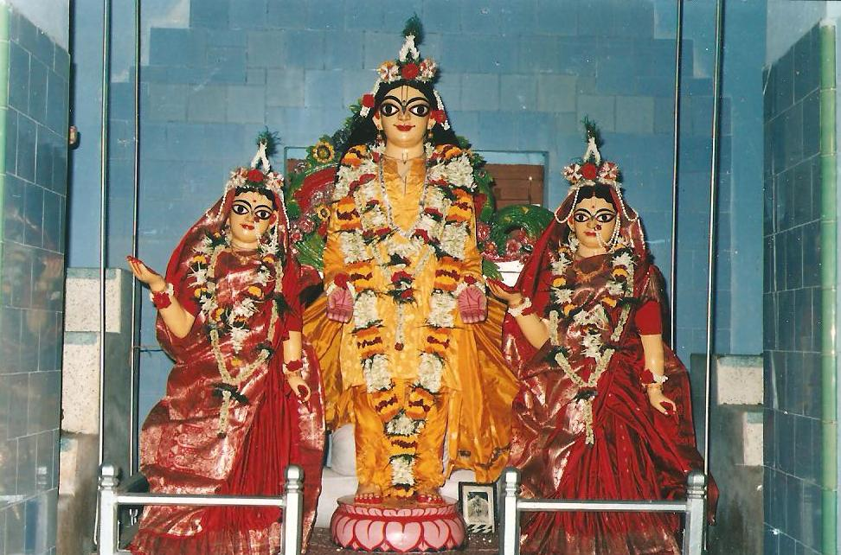
*Sri Sri Gour-vidhur-jayati*

Sri Sri Gândharvikâ-Giridhârou jayatah

HARE KRISHNA HARE KRISHNA KRISHNA KRISHNA HARE HARE
HARE RÂM HARE RÂM RÂM RÂM HARE HARE

The first English Râgânugâ magazine

YEAR 1 : Issue no. 03 Sri Gourângâbda 522 Month: Madhusudan 15 Apr’07 to 15 May’07

Noumi tang gourachandrang yah kutarka-karkasha-âshayam,
Sârvabhoumang sarbhumâ bhakti-bhumânam-âcharat.
Vairâgya-vidya-nija-bhakti-yoga-shikshârtham-ekah purusha purâna,
Sri-krishna-chaitanya-sharira-dhâri kripâmbudhir-yastam-ahang prapadye.

“Dry arguments had hardened Sârvabhouma Bhattâchârya’s heart, but Sri Goursundar drenched it with supreme Bhakti. I pay obeisance to Such Supreme Personality Sri Gourânga Mahâprabhu. He imparted the knowledge of material detachment and how to perform His Own Bhakti. He is the One, only Supreme Personality Who is the Ocean of Mercy, and now He has appeared as Sri Krishna Chaitanya. I take shelter unto Him.” - (C.C. 2.6.1, 2.6.20)

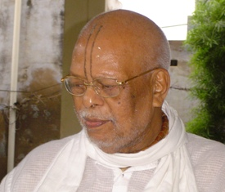
Chief Editor of Guidance in Love:
108 Sri Srimat Ananta das Babaji Maharaj, Pandit and Mahant of Radhakund.

In this issue

Cover Photo – Lord Nityananda, Mâ Vasudhâ (on His right) and Mâ Jâhnavâ (on His left) in Their wedding attire. Please note that The Lord is with His arms extended. He is saying – “Come into my arms. Give me all your sorrows and troubles. Give me prem.” Baba calls this the ‘prem-bhikshâ’ pose. We find that starting with Sri Bishnupriyâ devi (as we saw in the cover photo of the last month) our Goswamis have preferred this pose. We can get darshan of Their Lordships in the original Sribâs-angan, Nabadweep.

Please SELECT the topic you want and press Ctrl and Click. You will go to the topic of your choice.

Holy Invocation – Our Shâstras contain many prayers that express love for Ishtadev. In this issue, we present a prayer from Sri Chaitanya Charitâmrita.

- Sri Shachi-tanaya-ashtakam – Sevâ-aparâdhs are another barricade in Bhakti. All the saints and Shastras state that the only way to get rid of sevâ-aparâdhs is to sing various glorifications. (Of course, we must also beg forgiveness from Our Lordships.) Which are the Râgânugâ hymns that we must sing daily? The minimum requirements are the glorifications of –

  - Sri Vaishnav
  - Sri Gurudev
  - Sri Goursundar
  - Sri Nityânanda Prabhu
  - Sri Advaita Prabhu
  - Sri Govinda
  - Sri Râdhârâni

In this issue, we present ‘Glorification of Sri Goursundar - the Son of Shachi-Mâtâ’ by Srila Sârvabhouma Bhattachârya. The Bhajanânandi Vaishnavs in Radhakund recite some prayer-songs (popularly known as ‘ashtakams’) daily on a compulsory basis. We must try to memorize these hymns so that it is easier for us to recite them anywhere and everywhere. - Page 5

- With love from the Editor – Babaji Maharaj’s message for spiritual seekers

- Our sweet Lord of Love - Sri Gourhari - Glimpse into the life of our Beloved Sri Gourânga Mahaprabhu, the Love Incarnate

- Leelâ-smaran (Nishânta-leela) – Mahâjan Poems – contributed by Minaxi dâsi
  - Râdhâmohan dâs
  - Balarâm dâs

- Goursundar’s beloved Deity – Sri Jagannâthdev

- Saint of the month – Ishwari Sri Jâhnavâ Mâtâji

- Kânu plays prank on Ishwari – by Sri Vasu Râmânanda (of our Yogpeeth)

- Sri Râdhâ’s Boat-ride – by Sri Gyâna dâs

- Sri Govinda’s reply (to the accusation in the above poem) – by Sri Jagannâth dâs

- Srimati Râdhârâni’s kitchen – Our Ishwari loves to cook for Her Beloved Govinda

- Bhakta-kripâ – Mail from devotees
- Love-feasts at a glance – Your monthly Almanac



Sixteen shingâr of Sri Râdhâ
(How we should dress up Ishwari completely)
- bathe Her nicely
- place a large pearl nose ring on Her nose
- blue dress
- use a silk (highly decorated) ribbon to
- tie Her hair in a plait
- ear rings in both the ears
- decorate Her with chandan design
- put flowers in Her hair
- place a garland round Her neck
- place a lotus in Her hand to play with
- offer tâmbul in Her mouth
- draw beauty-spot on Her chin with kasturi (musk)
- kohl in the eyes
- draw colorful designs of leaf etc. on Her bosom and face
- âltâ on Her feet
- sindoor dot on Her forehead and surround it with chandan design.

An ode to the Son of Mother Shachi

By

Srila Sârvabhouma Bhattâchârya
Part 2

Chanchala-châru-charana-gati-ruchirang
Manjira-ranjita-padayuga-madhurang,
Chandra-vinindita sheetala-vadanang
Tang pranamâmi cha sri shachi-tanayang .5.

Chanchala - swift; châru - expert, deft; charana-gati - movements of feet; ruchirang – graceful; Manjira – anklets; ranjita – decorated; padayuga – feet; madhurang- sweet; Chandra-vinindita – puts the moon to shame; sheetala – soothing; vadanang – face; tang – Him (That) pranamâmi – I pay obeisance cha – and; sri – beautiful; shachi-tanayang – the Son of Shachi devi.5.

Meaning – “His lotus-feet dance so swiftly, in an expert and graceful manner. Tinkling anklets decorate His sweet rosy feet and His face is so cooling that it puts the full moon to shame. I pay obeisance unto That beautiful Son of Mother Shachi.”5.

Dhrita-kati-dora kamandalu dandang
Divya-kalevara mandita-mandang,
Durjana-kalmasha-khandana-dandang
Tang pranamâmi cha sri shachi-tanayang .6.

Dhrita – (He) holds, bears, wears; kati-dora – string aound the waist for the loin cloth; kamandalu – water-pot; dandang – staff; Divya – divine; kalevara – body; mandita-mandang – looking beautiful and radiant; Durjana – evil people; kalmasha – sins; khandana – to destroy; tang – Him (That) pranamâmi – I pay obeisance cha – and; Sri – beautiful; shachi-tanayang – the Son of Shachi devi.6.

Meaning – “He bears only a waist-string to hold the loin cloth, a water-pot and a staff. His divine body, thus decorated, looks beautiful and radiant. Whosoever beholds this beautiful form, how much ever evil he may be, Goursundar destroys all his sins. I pay obeisance unto That beautiful Son of Mother Shachi.”6.

Bhushana-bhuraja-alakâ-valitang
Kampita-vimbâdhara-vara-ruchirang,
Malayaja-virachita-ujjwala-tilakang
Tang pranamâmi cha sri shachi-tanayang.7.

Bhushana – Ornaments; bhuraja – dust of the earth; alakâ – locks of hair; valitang – curly, surrounded by ; Kampita – quivering; vimbâdhara – lips that are rosy like the berry; vara – exquisite; ruchirang – finely-shaped; Malayaja-virachita – design drawn with sandalwood paste; ujjwala – Brilliant; tilakang - tilak; tang – Him (That); pranamâmi – I pay obeisance ;cha – and; sri – beautiful; shachi-tanayang – the Son of Shachi devi.7.

Meaning – “Ecstatic with Sri Krishna-prem, He rolls on the earth in Sri Radharani’s bhâv – the dust of the earth then becomes His sole ornament. Even His beautiful curly locks are bathed in dust. His fine, exquisite, berry-like lips tremble in love-ecstasy, yet (in spite of rolling in the dust) His chandan-tilak sparkles ever so brilliantly! I pay obeisance unto That beautiful Son of Mother Shachi.” 7.

Nindita-aruna-kamala-dala-lochanang
Âjânu-lambita sri-bhuja-yugalang,
Kalevara-kaishora-nartaka-veshang
Tang pranamâmi cha sri shachi-tanayang .8.

Nindita – putting to shame; aruna - (pink) dawn; kamala-dala – lotus-petals; lochanang – eyes; Âjânu-lambita – reaching His knees; Sri – beautiful; bhuja-yugalang – two arms; Kalevara – body; kaishora – budding youth; nartaka-veshang – poised in dance; tang – Him (That) pranamâmi – I pay obeisance cha – and; sri shachi-tanayang – the Son of Shachi devi.8.

Meaning – “His eyes are large and beautiful like lotus petals - with the tips so rosy that they put the dawn to shame. He looks like a handsome budding youth and His beautiful arms reach His knees. I pay obeisance unto That beautiful Son of Mother Shachi.” 8.
iti-srila-sârvabhouma bhattâchârya-virachitang sri sri shachi-tanaya-ashtakang-sampoornang.
Thus ends “An Ode to the Son of Mother Shachi” composed by Srila Sârvabhouma Bhattâchârya.

GO TO INDEX



My dear devotees,

In Sri Krishna-Karnâmritam, Sri Lilâshuk has echoed Sri Râdhârâni’s feelings. She says- “O my Beloved Shyâm! As long as You are pleased with me, I do not care if others are displeased. But if You are displeased with me, then can we gain anything by pleasing others?” – (Verse 29)

My dear good devotees, we are Srimati’s maidservants. Therefore, we must study Her bhâv most carefully. We must realize that if Sri Govinda showers His mercy, then even the rarest objects come within our reach. If He is displeased, what is the need for any Sâdhanâ, for then thousands of obstacles will occur in the path of our Sâdhanâ. Without Sri Krishna’s mercy, the sâdhak can never achieve the fruit of his Sâdhanâ. The sâdhak realizes his goal only when Sri Krishna adds His Kripâ to his enthusiasm for Bhajan. Without Kripa, Sâdhanâ bears no fruit. Juicy sugarcane will yield its juice only when we squeeze it. Similarly, Sri Bhagavân is full of kripâ–ras, but it does not flow out until the sâdhak is enthusiastic about his sâdhanâ. Hence, we have to perform our Sâdhanâ enthusiastically in order to squeeze out the Kripa–ras from Sri Krishna. Therefore, if we are intelligent, and self–surrendered, we shall continue to observe all the principles of Bhakti and constantly wait for our Ishtadev’s mercy. We find in Srimad-Bhâgavatam –

Brahmâji is praying –“O Lord! The one who awaits Your mercy, and suffering the fruits of his Karma, surrenders unto Your lotus-feet with body, mind and speech, and spends his life in Your Bhajan (hearing, chanting, remembering etc.) he is entitled to gain the service of Your lotus-feet.” -[S.B. 10.14.8]

Ishwari is crying out from the bottom of Her heart – “O Krishna! For us, hearing Your name itself is supremely gratifying and it is the source of our life. If You do not nourish us with Your flute and then cast Your glance at us, then how can we express our feelings? We shall consider it the greatest and rarest fortune!”
- (Sri Krishnadâs Kavirâj Goswâmi in his purport to Sri Krishna-Karnâmritam)

We, as Srimati’s manjaris, must also cry - “If You are pleased, we seek nothing else. And if You are displeased, what is the need for anything?”

Wishing you all the best,

Your servant

Ananta das.

GO TO INDEX



The life and teachings of Sri Gourânga Mahâprabhu - the Love Incarnate

Bujhe ba nâ bujhe keho, shunite shunite seho,
ki adbhut Chaitanya charit,
Krishne upajibe preeti, jânibe raser reeti,
Shunilei hoy boro hit.

“Sri Chaitanya Mahâprabhu’s life is so wonderful that if we hear constantly although we may not understand anything, we shall gain love for Krishna and learn the doctrine of rasa. It behooves good even if we simply hear it.” - (C.C.2.2.76)

[A compilation of Sri Chaitanya Bhâgabat by Vyâs-avatâr Sri Vrindâvan dâs Thâkur, Sri Chaitanya Charitâmrita by Srila Krishna dâs Kavirâj Goswâmi, Sri Chaitanya Mangal by Sri Lochan dâs Thâkur and Sri Bhakti-Ratnâkar by Sri Narahari Sarkâr Thâkur]

Part 3
The Divine Child

Sri Gourachandra grew brighter day by day just like the phase of the moon during the bright fortnight. He caused great joy to His parents –Shachi Mâtâ and Jagannâth Mishra.
putrer srimukh dekhi brâhmani brâhman,
Ânanda-sâgare donhe bhâse anukshan.
“When the Brahmin couple saw the moon-like face of their Son, they floated in the ocean of happiness.”

The Lord performs leelâ with Ananta-nâg, His Supreme Devotee

Shachi Mâtâ and Jagannath Mishra were indeed blessed, since the Supreme Personality Himself performed His Divine Pastimes in their courtyard. The Lord would move about everywhere fearlessly. He caught whatever was within His reach – fire, snake, or anything that He fancied. One day He caught a snake – “ekdin ek sarpa bâdite bedây, dhorilen sarpe prabhu bâlak leelây.” The snake curled up around Him, while Prabhu lay peacefully on it. After all, He was none other than Sri Nârâyan Who lies on Shesh-nâg. When the people saw this, they were extremely frightened and cried, “Alas! Alas!” However Prabhu just laughed. Then they called out “Garud! Garud!” Shachi and Jagannâth burst into tears. Seeing this -
Chalilâ Ananta shuni sabâr krandan,
Punoh dharibâre jân Sri Shachinandan
“Lord Anantadev (Shesh-nâg) took mercy and left. But Sri Shachinandan was still not done with meeting His devotee. So He went to catch Him again.” Everyone rushed forward and dragged Him away. Sri Vrindâvan dâs Thakur promises that, “Whosoever hears this leelâ, the poisonous snake of materialism will never bite him, and he will gain Sri Gourhari’s mercy.”

Beauty of Child Goursundar

Slowly the Lord started walking. Srila Vrindâvan dâs Thakur has described the Lord’s fantastic beauty at this time.
Jiniyâ kandarpa-koti sarbânger rup,
Chânder lâgoye sâdh dekhite se mukh.
Subalito mastake chânchar bhâl-kesh,
Kamala-noyon, - jeno gopâler besh.
Âjânulambito bhuja, arun adhar,
Sakal-lakshanjukta baksha-parisar.
Sahaje arun gour-deho manohar,
Bisheshe anguli, kor, charan sundar.

“Every part of His body was beautiful like crores of Kandarpas (Love-gods). His face was so infinitely beautiful and sweet that it put to shame the beauty of countless moons. Hence, even the moon wanted to see Him. Smooth, black and glossy curls tumbled down His forehead. His eyes were like lotus-petals. His strong arms reached His knees and His lips were rosy like the berry. His chest was flat and vast. He looked just like Sri Krishna of Vrajadhâm. There was only one difference – He was remarkably golden (since Sri Râdhikâ’s splendor and bhâv covered Him). Although every part of His body was beautiful, His fingers, palms and feet were especially so.

The Lord starts preaching

Even as a baby, the Lord preached Harinâm. He danced and laughed – nirabadhi nâche, hâshe - as long as He heard Harinâm – shuni haridhwani.

Tâbat krandan kore, prabodh nâ mane,
Boro kori haridhwani jabot nâ shune.

“The Lord continued to cry and no one could pacify Him until they cried “Haribol!” loudly. It became a regular affair for the people to visit Jagannâth Mishra’s home every dawn and perform Harinâm Sankirtan around the Baby. They would clap and sing Harinâm, and the Child Goursundar would dance most happily. As a child, Goursundar was very playful. Nobody had the power to hold Him in one place. He would rush out of the house and beg the passers-by for pop-rice (khoi), bananas, sandesh (a popular Bengali sweet) or anything else He found them carrying. His beauty was so enchanting that even the one who did not know Him, would be spellbound and give Him whatever He asked from them – dekhiyâ prabhur rup parama-mohan, je jon nâ chine, seho dey totokhon. And what did the Lord do with all these offerings? He simply gave them away to – je sakal strigone gâyen harinâm – the women who sang Harinâm for Him. Everyone marveled at His intelligence and sang “Hari! Hari!” all the more.

Naughty Gourânga

The Lord was naughty as He was playful. After all naughtiness was His inherent nature. Who can forget how much He had troubled the Vrajavâsis? In this swarup also He would always roam out of His house – be it day, afternoon, evening or night. He would amuse Himself by stealing everyday from some or the other house. After all, He basks in glory when devotees crown Him with the title –“Choura-agra-ganya (the Chief of the Thieves)”. In Nabadweep-leelâ, He kept up His reputation by – kâro ghore dugdha piye, kâro bhât khây, hândi bhânge jâr ghore kichhu nâhi pây – “He entered someone’s house and stealthily drank up the milk, while He ate up all the rice from another house. Fed up of His antics, the house owners hid everything, beyond His reach. But even then they had no respite, for, if He did not get anything, He would break all the pots and pans.”

As if this is not enough! He had some more pranks up His sleeve. Jâr ghore shishu thâke, tâhâre kândây – He would pinch the babies and make them cry, and sometimes even pour water in their ears. It was very difficult to catch Him in the act. So the parents could not even complain. If accidentally, they ever caught Him, He would become the embodiment of humility. He would fall at their feet and beg forgiveness so sweetly that it would move everyone to tears. They would immediately clasp Him to their bosom.
Thieves steal Nimâi

One day, the Lord wandered far from His home. Two thieves saw the golden complexioned Child and they were most attracted. When they saw the glittering ornaments on the Lord, their greed crossed all bounds and – horibâre dui chor chinte parakâr - they conspired to kidnap Him. One of them called out sweetly to Him. He said, “Come, here, my child” and picked Him on his lap. “We will take you home,” they said. Nimâi smiled at them and said happily, “Yes, come let’s go home.” Little did the thieves realize that He was calling them Home – the original Home of every being – Sri Golok Vrindâvan? The thieves lifted Him and quickened their steps. The passers-by thought the child belonged to them, since He was accompanying them so happily. The thieves were fully confident they had bagged a large booty.

Keho mone bhâbe, - ‘mui nimu tâd-bâlâ’,
Eimote dui chore khây monohkolâ.

“Each thief was planning what he would take when they would share the loot. One of them had already decided on the armlets and bangles. In this way they were busy building castles in the air.”

The thieves were walking towards their hiding place, while the Lord just sat on their shoulders and laughed. One of them even gave Him some sandesh. The other thief lied, “Here we have nearly reached home.” In this way, they carried Him for a long time. All of a sudden, they found themselves surrounded by a group of people. They all came rushing at them, crying in relief. There was quite a commotion, since the child had been missing for quite some time. Nimâi’s parents and relatives were feeling like - jol binâ jeno hoy matsyer jibon - fish out of water. Some said, “Come, come Vishwambhar, where had you been, my dear boy?” while another person called out - “Nimâi!” Surprisingly the thieves felt as if they had reached their hiding place. How they were eager to lay their hands on His ornaments!

Chor bole, - ‘nâmo bâp, ailâun ghor’,
Prabhu bole, - ‘hoy hoy, nâmâo satvar’.

“The thieves said, ‘Get down, child, we have reached home’. The Lord said, ‘Yea, yea, that’s right. Get me down quickly.’”

Jagannâth Mishra was sitting with his head in his hands. He was a picture of misery. As soon as Prabhu climbed down from the shoulders of the thieves, He ran into Jagannâth Mishra’s arms. Everyone roared “Hari! Hari!” in exultation. They felt like dead bodies come alive – prân âshi deher hoilo jeno sanga.

And what about the thieves? Well, when they discovered what had happened and before the commotion got any louder, they decided to make a sprint. They stopped only after they had reached their hiding place. Once there, they heaved a sigh of relief. They embraced each other and said, “Chandi râkhilen âji – the Mother Goddess has protected us”. (The thieves in Bengal worship Goddess Durgâ or Kâli before each venture).

Vyâs-avatar Vrindâvan dâs Thâkur says –

“The thieves were inexpressibly fortunate. Thousands of sâdhaks, although they may perform thousands of sâdhanâ, do not get the opportunity to serve Sri Bhagavân. Even exalted beings such as Brahmâji do not get such an opportunity. Yet, in spite of being thieves, they had carried Sri Gour-nârâyan on their shoulders!”

Every one asked Him, “Dear child Nimâi, tell us, who brought you here? And from where?” The Lord replied –

ami giyâchhinu gangâ tire,
poth hârâiyâ âmi bedâi nagare.
Tobe dui jon âmâ kolete koriyâ,
kon pothe eikhâne thuilo âniyâ.

“I had gone to the banks of the Gangâ. Then I lost my way and wandered here and there. Two people just came along, picked me up on their laps and I do not know which way they brought me here.”

In this manner, the Lord of the Spiritual world performed many charming pastimes. Who can comprehend them without His mercy – “ei moto ranga kore baikunther rây, ke tânre jânâte pare, jodi nâ jânâ?”

Bed-gopya e-sob âkhyân sei shone,
Tânr dridha bhakti hoy Chaitanya-charane.

“These pastimes are unknown even to the Vedas. Whosoever hears them, gains firm devotion at the lotus-feet of Sri Chaitanya Mahâprabhu.”

(To be continued)

GO TO INDEX



Nishânta-leelâ
Rasâlas or love-languor

Nabadweep-meditation
(Lalit Râg)
By
Sri Râdhâmohan dâs
(contributed by Minaxi dâsi)

Rajaniko sheshe jâgi shachi-nandana
Shunaite oli-piku-râb,
Sahajahi nija-bhâbe garagara antara
Tahin uhu dwitiya bibhâb.

“Shachinandan, Sri Gourhari awoke on hearing the warbling of the cuckoos and the buzzing of the bees at the end of the night. He was lost in His Own love-ecstasy, when another mood arose in Him.”

Bekata goura-anubhâb,
Puraba-rajani-sheshe jâgi duhun jaichhana
Upajala taichhana bhâb.(repeat after every stanza)

“Now Goursundar displayed a secondary mood, that was just like the one expressed by the Divine Couple when They awaken at the end of night.”

Nayana-amala-jala omiya-bachana khala
Pulake bharala sob anga,
Harisha bishâd shankâdi puno uyoto
Ko koho bhâb-taranga.

“His eyes overflowed with tears and Ambrosial speech escaped His lips, while goose bumps covered His body. Various feelings flooded His heart – joy, sorrow, fear. How can I express the waves of bhâv that surged in Him?”

Aichhana anudin bihore nadiyâ-pure
Puraba-bhâb parakâsh,
So anubhaba kobo majhu mone hoyaba
Koho râdhâmohan dâs.

“In this manner Sri Goursundar sports divinely in Nabadweep – expressing His past bhâv. Poet Râdhâmohan dâs wonders –‘When will such ras-realization awaken in my heart?’ ”

Vrindaban-meditation
(Vibhâsh Râg)

By
Sri Balarâm dâs

Meetala chandana tutala abharana
Chhutala kuntala bandha,
Ambara khalita galita kusumâbali
Dhusar duhun mukha-chanda.

“The sandalwood paste got wiped off, the ornaments broke and the chignon loosened; the robes slipped, the garlands broke and Their faces turned hazy (with perspiration).”

Hari hari aba duhun shyâmara gori,
Duhunko parashe-rabhase duhun murachhito,
shootala hiye hiye jori.(repeat after every verse)

“Hari! Hari! Now both Shyâm and Gori (Râdhârâni) have fainted out of tremendous excitement of touching one another and have fallen asleep with their bosoms clasped close.”

Râiko bâm jaghana para nâgara
Dâhino charanahi âpi,
Naolo kishori agori koro pohu
Ghumala mukhe mukha jhâmpi.

“Nâgar placed His right foot on Râi’s left thigh while She – just in Her blooming youth – slept peacefully covering Her face with His.”

Kiye madana-shara-bheetahi sundari
Paithali piyo-hiyo mâho,
Kobo balarâm nayana bhari herobo
Korobo omiyâ abagâho.

“How my beautiful Râdhârâni has pierced Her Beloved’s heart like the Love-god’s arrow! O when will poet Balarâm dâs get to behold this Ambrosial Beauty to his heart’s content?”

GO TO INDEX


Goursundar’s beloved Deity

Part 2

In the auspicious month of Kârtik, Jagannâth dev dons new attire. The devotees call it the ‘Râdhâ-Dâmodar vesh’ or ‘Râi-Dâmodar vesh’. Râi means Sri Râdhâ, while Sri Krishna is Dâmodar. During this time Jagannâth dev wears seven types of garlands. He sports five different looks from Ekâdashi to Purnimâ. Lady Subhadrâ dresses up as Srimati Râdhârâni. Sakhis made of sholâ surround Srimati. How did this look originate?

Once Mohâpâtra, a sevak (servant) of Jagannâth Mandir offered the King a prasadi flower of Sri Jagannâth dev . In reality, it was a flower from his girl friend’s hair. He was still unmarried. He had been in a great hurry. So out of confusion, he presented it to the King instead of a flower from Sri Jagannâth dev’s garland. The King was most puzzled to find a hair entangled with the flower. It enraged him. “How dare the priest offer the Supreme Lord flowers entangled with hair!” he bellowed. Now the sevak was a pure devotee of the Lord. The moment he became aware of his mistake, he started trembling in fear. He knew that the King would surely carry out an inspection the following day. Therefore, he put a wig on Jagannâth dev’s head and covered it with flowers. Gajapati Râjâ was most surprised to find Jagannâth dev with hair on His head. He realized the sevak was pulling a fast one on him. One tug at that wig, and that all would come loose.

But lo and behold! As soon as the King tried to pull off the wig from Lord Jagannâth’s head, blood started trickling down. The Râjâ realized that the Lord was oozing the prem of the sevak. The Raja felt as if this was a small example of Sri Sri Râdhâ-Krishna’s ever-new prem. The Rajah decided to commemorate this occasion by dressing up Their Lordships as ‘Râdhâ-Dâmodar’.

Another very important look is ‘Navânka-vesh’. Sri Gourânga Mahâprabhu had started this look. Srimanmahâprabhu wanted to show the Lord of the world in the form of ‘The Nine fold Bhakti’. The ‘Nine fold’ Bhakti comprises of – shravan (hearing ), kirtan (chanting), smaran (meditation), archan (worshiping), pâda-sevan (serving His feet), vandan ( praying), dâsya (servitude), Sakhya (friendship) and âtma-nivedan (self-surrender). Srimanmahâprabhu called these as ‘Navânka’ (the Nine Parts). Jagannâth dev looks like a lover when He dresses in the ‘Navânka-vesh’. He wears a hand-woven white dhoti with bright red border. He looks very lovely.

During Makar-sankrânti (when the Sun’s rays fall directly on the Tropic of Capricorn), Jagannâth dev dons the Makar-dress. He wears a huge crown made of Tulasi leaves. He really looks like the King of infinite universes. We beg to present a few of some more ‘Jagannâth-styles’.
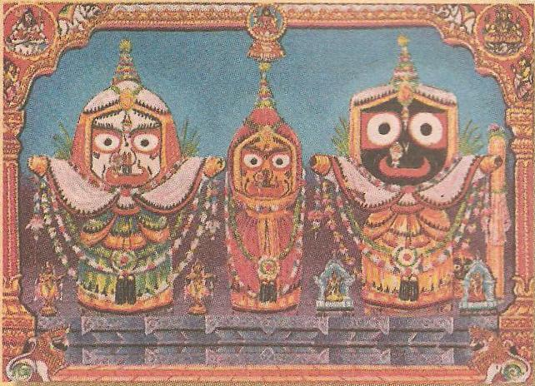

Sri Râdhâ-Dâmodar Vesh (attire)
of Lord Jagannâth during Niyam-seva

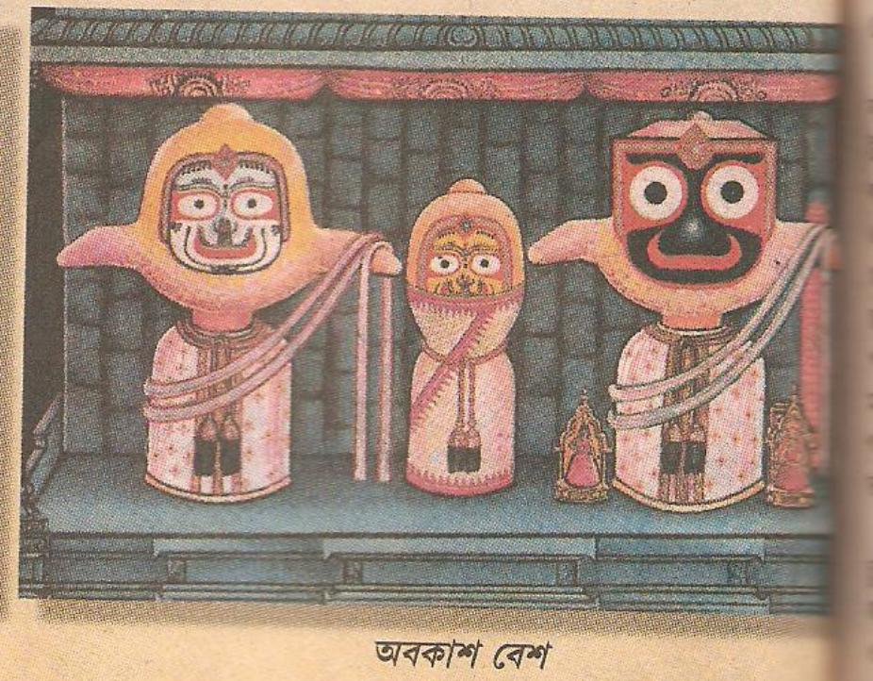
Lord Jagannâth’s dress when He is resting.
The devotees call it ‘Avakâsh-vesh’.

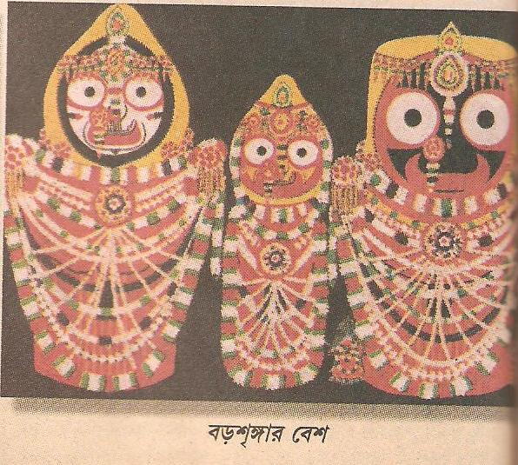
Jagannâth dev’s big fashion ( boro shringâr vesh)
GO TO INDEX

Come Ashtami in the bright fortnight of Madhusudan and Radhakund gears up to celebrate one of the most ecstatic festivals of the year – Sri Jâhnavâ Mâtâji’s Appearance Day.

Sri Gour-ganoddesh Dipikâ says –

Shri-vâruni revatyor-amsha-sambhave,
Tasya priye Sri-vasudhâ cha jâhnavâ.
Sri-surya-dâs-âkhya-mahâtmanah sute,
Kakudmi-rupasya cha surya-tejasah.

Meaning – “Sri Nityânanda Prabhu’s beloveds – Sri Vasudhâ and Jâhnavâ devi were Vâruni and Revati in Dwâpar Leelâ. Sri Suryadâs Sarkhel, their father was the same as Kakudmi, the King of Raivata. He was lustrous like the Sun-god.”

Sri Suryadâs Pandit lived in Shâligrâm. He had five brothers –viz. Dâmodar, Gouridâs, Krishnadâs and Nrisimha-chaitanya. His father was Sri Kamsâri Mishra and mother was Srimati Kamalâ devi. Suryadâs was the accountant of The Nawab of Bengal. So the Nawab had conferred the title of ‘Sarkhel’ on him.

Suryadâs had two daughters – the elder one was Sri Vasudhâ and the younger one was Sri Jâhnavâ.

Jâhnavâ Mâtâji’s marriage to Lord Nityananda was highly sensational. Sri Vaishnavpada dâs Bâbâji, the highly esteemed disciple of Most Worshiped Ananta dâs Bâbâji Mahârâj narrated it during his Harikatha on Sri Chaitanya Chandrâmritam.

When Srimanmahâprabhu ordered Lord Nityananda to marry and establish an example for the ideal grihastha, He approached Suryadâs Pandit. However, the Pandit refused saying, “You are an avadhut. Neither Your caste nor creed is certain. No one even knows where You belong.” When our dear sweet Nityananda Prabhu humbly protested, saying that he was a Brahmin as any Brahmin worth his salt- (after all He was the son of Hâdai Pandit) –Suryadâs sarcastically commented that it was very much evident from the regulative principles He followed – Nityânanda Prabhu did not follow the rules of the caste system at all. Hearing this, the Lord left in silence. (“We must never consider the caste of a Vaishnav since he is above all the castes.” – C.C.)

Now, inside the house, Vasudhâ Mâtâji had been hearing the entire conversation with utmost interest. She had been ecstatic when the Lord had arrived with the proposal. When her father thwarted the proposal, She became so miserable that she swooned on the floored. All the inmates of the house came rushing to her side. They called the doctor. Even he could not revive her. Then they called a conference of the Brahmin Pandits. All the elders agreed that the life of the girl mattered the most, and for that Suryadâs should agree to her marriage – never mind if it was someone like Nityânanda Prabhu. The doctor (supported amply by the Brahmin Pandits) exhorted him to bring Nityânanda Prabhu back to the house as quickly as possible. The chances of Vasudhâ Mâtâji’s revival seemed very slim since quite some time had passed. The Lord had arrived from across the Ganga in a personal boat and He had certainly left by then. The friends of the family ran helter-skelter towards the Ganga – only to find – the Lord sitting in a very relaxed mood under a tree, as if waiting for them. He readily accompanied them back to the house. As soon as the Lord touched Vasudhâ Mâtâji, she, who was His eternal consort, immediately opened her eyes. Suryadâs arranged a huge feast to celebrate the wedding.

Sri Krishna dâs, the son of Raja Hari-hod of Bodgâchhi carried the entire expense of the wedding on Sri Nityânanda Prabhu’s behalf. He was an ardent devotee of the Lord and he begged the Lord to start the wedding procession from his house. The merciful Lord complied with the wish of His devotee. Srivâs, Sri Advaitâchârya, Sri Chandrashekhar and Sri Murâri Gupta collected and started the Sankirtan party. Sri Suryadâs Pandit’s brother Sri Krishnadâs Pandit came to Bodgâchhi to pick them up and he took them to Shâligrâm. When Suryadâs Pandit saw the Sankirtan party, he came and greeted them. He accompanied the Divine Bridegroom and His followers to his house and prostrated himself at His lotus-feet.
Lotâiyâ pode nityânanda padatale,
Surjadâs bhâse dui nayaner jole.
Dui hâate dhori charan dukhâni,
Kohite châhoye kichhu nâ sphuroye bâni.
Manda manda hâsi nityânanda premâbeshe,
Kripâ kori koilâ âlingan surjadâse.
Surjadâs ânande bihbol nirantar,
Ke bujhite pâre surjadâser antar.
Dekhiyâ bhrâtâr prem-cheshtâ gouridâs,
Nâ dhore dhairaj, ati antare ullâs.

Meaning – “Suryadâs rolled beneath Lord Nityânanda’s feet and floated in tears. He clasped the Lord’s feet with both the hands. He tried to speak, but could not. The Lord smiled and picked him up with love. He was full of mercy and embraced His devotee. Suryadâs was overwhelmed with love-ecstasy. Who could understand his feelings? When his brother Gouridâs Pandit, who was a devotee par excellence, saw his prem, he could not control himself – he was exultant!” – (12th wave, Sri Bhakti Ratnâkar)

Let us hear the remaining part of the story from our dear and most esteemed Guru-brother Sri Vaishnav-pada dâs Babaji.
In India, when the bridegroom arrives, he is kept in a room away from the bride. Here only his close friends accompany him. The bride’s friends wait upon them with refreshments. They get a free hand to play all sorts of pranks and pull many practical jokes on the groom and his friends – so much so – that they get mortally scared of the experience. One of the common pranks the girls play on the boys is this – they very sweetly offer tâmbul – the boys simply cannot refuse such overtures, you see. Now how could they suspect that such innocent-looking tâmbuls, offered by more innocent-looking maidens could possibly contain Neem paste, whole betel nuts, red chilly, or horror of horrors, intensely concentrated hashish! But then, our Nityânanda Prabhu was not the One to be taken in so easily. He gripped her hand very tightly indeed! Whose hand, you ask? Why, Jâhnavâ Mâtâji’s of course! Was she not trying to force one of those ‘innocent’ tâmbuls into his rosy mouth?

“SURYADÂS! SURYADÂS!” called the Lord. Suryadâs Pandit came trembling inside. “Where is my dowry?” – Prabhu bellowed. Suryadâs fell at His feet, “My Lord, everything I possess belongs to You.” “And yet you keep this gemstone hidden in your coffer?” asked the Lord. “I want you to offer this precious nugget as dowry to me.” And Suryadâs Pandit was exultant. It matched exactly what he had seen in a dream some days ago – he had seen that he was giving away both his daughters in marriage to the Lord. Lord Nityânanda married the two sisters at the same altar. He wanted Mâ Jâhnavâ to preach and propagate the true teaching of Gaudiya Vaishnavism.
Mâtâji anchored and spearheaded the movement for a long time after the disappearance of the Lord. She held all the devotees together under her loving care. The Râgânugâ devotees belonging to her parivâr are indeed fortunate, for she is none other than Sri Ananga Manjari, Srimati Râdhârâni’s younger sister. Let us remember her with love and reverence on 22 April.

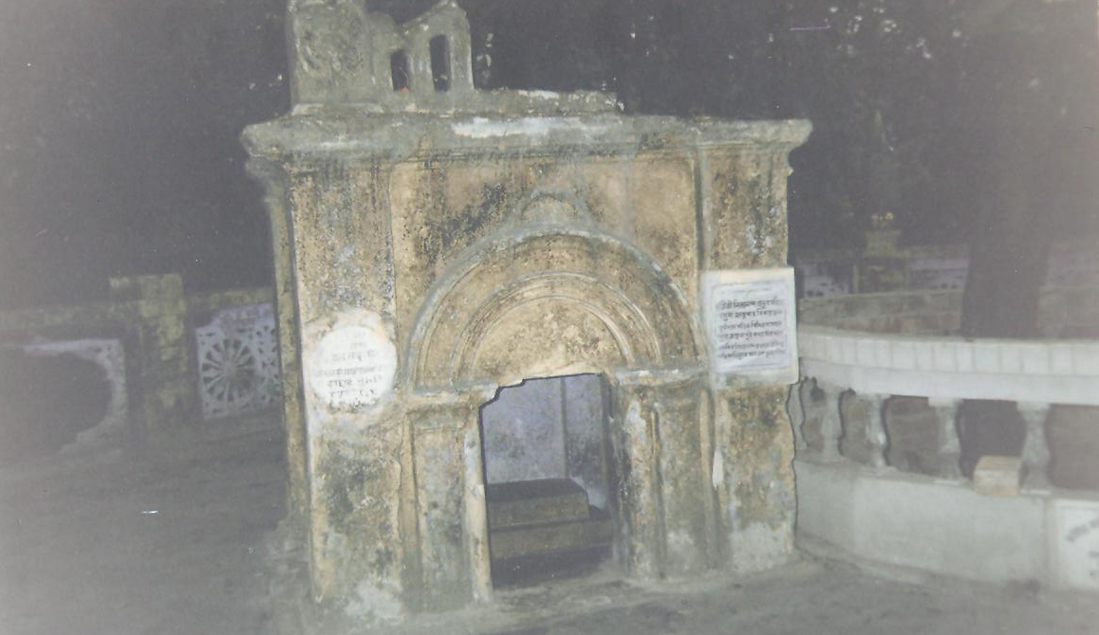
Suryadâs Pandit’s house in Kâlnâ. The marble inscriptions read -“This is where Lord Nityânanda married Ma Vasudhâ and Jâhnavâ.” We can see the wedding ‘mandap’ (the dilapidated structure)in the picture. Do you see the raised altar made of black stones inside ? This is where the Lord and His beloveds sat for the marriage. GO TO INDEX

A poem

By

Sri Vasu Râmânanda

[ Sri Râdhâ had gone alone on the banks of the Yamuna. It was evening and the sun god was about to bid farewell. Kânu was standing under the Kadamba tree, observing Her. His long shadow fell in the water. Râdhârâni thought that once again She was seeing the whole world full of Kânu. She thought Her mind was playing tricks on Her. As soon as She made a thrust in to the water. Immediately a host of bubbles arose. The picture of Shyâm was intact even in those bubbles. As She played with the water, Shyâm kept on appearing and disappearing. When the water stood still, He reappeared – as solid as ever.
The water symbolizes Sri Râdhâ’s heart. She is trying forcefully to wipe Kânu’s picture from Her heart. Sometimes, when She is extremely restless, Shyâm is present in Her various bhâvs (that keep on arising and submerging like the bubbles and waves of the water). Sometimes when She is lost in His meditation, His thoughts are more brilliant.

She says – “anurâge jale dubechhinu”. How true! She always remains immersed in the water, or shall we say ‘ocean’ of anurâg? ]

Beli abasân-kâle ekâ giyechhilâm jole
Joler hitore shyâma-rây,
Phooler chudâti mâthe mohana murali hâte
Puno kânu jalete lukây.

“I had gone to the banks of the Yamunâ in the evening. Whom should I see in the water, but Shyâm-rây? There He was with a crown of flowers on His head, and the enchanting flute in His hand. Then Kânu hid Himself in the water.”

Jamunâte dheu dite bimba uthe âchambite
Bimber mâjhâre shyâm-rây
Chudâr taloni bâme tribhanga-bhangima thâme
Heriyâ se kul râkhâ dây.

“As soon as I made a thrust in the water, there arose a host of bubbles and within those bubbles there was Shyâm-rây – with His crown leaning to the left and standing in His inimitable ‘tribhanga’ style. It was difficult to keep up my reputation when I saw Him thus.”

Puno jol dite dheu kothâo nâ dekhi keu
Jol sthir hoile dekhi kânu,
Dhori dhori mone kori dhoribâre nâhi pâri
Anurâge jole dubechhinu.

“Again I threw the water up and He disappeared. When the water became still, there He was again! I kept on thinking –“Now I will catch Him” – but I could not. I only sank deeper in the water due to anurâg.”

Kor bâdâiyâ jai shyâmer nâgâl nâhi pâi
Kândite kândite âilâm ghore,
Hâay âmi abhâgini nâ pâilâm shyâm gunomoni
Sei dukhe hridoy bidore.

“I went around (inside the water), extending my arms, yet I could not touch Shyâm. I returned home weeping. Alas! I am so unfortunate – I could not get Shyâm – the Gem of Excellence! Due to this my heart is breaking.”

Bosu râmânander bâni shuno shuno binodini
Akârane jole dubechhile,
Bujhite nârile mâyâ jole chhilo anga-chhayâ
Shyâm chhilo kadamber mule.

“ Listen, listen, O Binodini! Listen to the words of poet Vasu Râmânanda! You drowned Yourself in the water for nothing at all. You did not get His trick – it was only His reflection in the water – He was standing all the while under the Kadamba tree (watching what You were doing).”

GO TO INDEX


By

Sri Gyâna dâs

Mânas gangâr jol ghana kore kol kol
Du kul bohiyâ jây dheu,
Gagane uthilo megh pabane bâdilo beg
Tarani râkhite nâhi keu.

“The water of Mânas Gangâ is surging high and its waves are rushing past both the banks. The sky is cast with dense clouds and the wind is blowing strongly. How can anyone hold the boat (my heart) steady?

Dekho sakhi nabin kândâri Shyâm-rây,
Kokhono nâ jâne kân bâhibâr sandhân
Jâniyâ chadhilun kene nây.

“Sakhi, look at the novice boatman – Shyâm-rây! Kânu doe not even know how to steer the boat. Oh, I knew this all along! How foolish of me to have got into this boat!”

Neyer nâhiko bhoy hâshiyâ kothâti koy
Kutil noyâne chây more,
Bhoyete kâmpichhe de e jwâlâ sohibe ke
Kândâri dhoriyâ kore kôre.

“However the boatman was not the least bit afraid. He was laughing and joking, casting crooked sidelong glances at me all the while. On the other hand, my body was trembling in fear and I could not bear the torture. So, ultimately the Boatman took me in His lap.”

Akâje dibas gelo noukâ nâhi pâr hoilo
Porân hoilo paramâd,
Gyâna dâs kohe sakhi thir hoiyâ thâko dekhi
Ekhon nâ bhâbiyo bishâd.

“The whole day passed just like that – we did nothing useful, the boat never reached the other side and our lives were at risk. Poet Gyâna dâs (in the bhâv of a manjari) says – Sakhi! Better, you lie quietly in His lap. Now is not the time to feel miserable.’’

GO TO INDEX


By

Sri Jagannâth dâs

shuno binodini dhani âmâr kândâri tumi
tomâr kândâri koho kâre,
tuwa anurâg prem- samudre dubechhhi âmi
âmâre tuliyâ koro pâre.

“Listen O Binodini! O my precious One! You are the boatman of my heart. How can You call me Your boatman, when I have drowned in the in the ocean of Your anurâg? Now please save me and get me across this ocean.”

Jogi bhogi nâpitâni tomâr lâgiyâ dâni
Ojhâ hoilâm tomâr kârone,
Tuwa anurâge more loiyâ phire ghare ghare
Tuwa lâgi korilun dokâne.

“To please You I became a beautician, to please you I became a tax-collector, for You I became a snake-charmer. Your anurâg has made me beg from door to door and once I had even become a shopkeeper for You.”

Râkhâl hoiyâ bone sada phiri dhenu sone
Tuwâ lâgi bane banachâri,
Âmâr piriti pâiyâ a bhângâ tarani loiyâ
Tuwâ lâgi hoilun kândâri.

“Whole day I roam in the forest as a cowherd boy, grazing the cattle –see, how You have turned me into a forest-dweller! I have brought my broken heart to You – please become the Captain of my ship (heart).”

Nâ bol kubol dhani ramaniro shiromano
Tuwâ preme ki nâ kori âmi,
Dâs jagannâthe koy nâ theliho rângâ pây
Jâti jibon-dhan tumi.

“Please do not speak harshly to me, O my Precious One! You are the crest-jewel of all women. I am ready to do anything for Your prem. Poet Jagannâth dâs says – O Ishwari! Please do not push me away from Your rosy feet, You are the treasure of my life.’’
GO TO INDEX


Srimati Râdhârâni’s kitchen

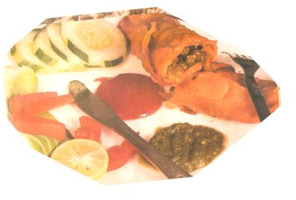

These pâpads are as delicious, attractive as they are full of protein. A sure hit with your Thâkurji as well as with the devotees during any feast.

By

108 Sri Srimat Ananta das Babaji Maharaj’s humble servant - Sâdhanâ dâsi

Ingredients:

Soya chunks – approximately 100 gram
2 large potatoes (boiled, peeled and cubed)
3 tomatoes (puréed)
Oil – 4 Tbsp
Pâpad – 4 large sizes
Water - 2 cups
Spices – asafetida, garam masala

- Boil soybean chunks for 5 minutes. Wash well with cold water. Squeeze. Put in a mixer and make small pieces. Do not make a paste – but only break it down to small pieces.
- Heat 1 tbsp oil in a pan. Add a pinch of asafetida and a few pieces of green chilly. Then add the potatoes and Soya chunks. Stir-fry. Add turmeric, salt and and half teaspoon sugar (optional). Evaporate the water. Add garam-masala. Remove from fire. Divide into 8 portions.
- Break the papads in half. Soak each part in water and immediately remove from the water. Put one portion of filling inside it. Roll it up. Do like this for all the pâpads.
- Add 3 Tbsp. Oil in the pan. When the oil is very hot, fry the rolls one by one on both sides.
- Heat 1 tbsp oil in a pan. Add the tomato puree, 1 pinch asafetida, salt, pepper powder. Sauté. Add 2 cups water. When the mixture starts boiling, gently add the pâpad rolls. Cover and simmer for 5 minutes. Sprinkle garam masala and finely chopped coriander leaves.
- Serve Sri Sri Gour-Govinda hot with tomato ketchup.

Note: - You may serve only the fried poplets to Their Lordships along with tomato ketchup during ‘snacks-bhog’ or make the gravy-type and offer with rice, bread etc for Râj-bhog.



GO TO INDEX

15th April to 15th May

Date | Day | Phase of the moon | Love-feast
15 Apr | Sun | 13th | -
16 Apr | Mon | 14th | -
17 Apr | Tue | New moon  (Amâvasyâ) | - Appearance day of Srila Gadâdhar Pandit Goswâmijiu  - Abhishek and grand feast in Sri Gadâdhar-Chaitanya Mandir, Radhakund  - Sri Vrajasundar dâs Baba’s Disappearance Day – Grand Feast in Barsana
18 Apr | Wed | 1st | -
19 Apr | Thu | 2nd | -
20 Apr | Fri | 3rd &4th | - Akshay tritiyâ  - Chandan Yâtrâ (Sandalwood festival)  - Appearance day of Lord Parashurâm
21 Apr | Sat | 5th | -
22 Apr | Sun | 6th | Grand Feast in honor of Sri Brindâban dâs Bâbâ’s Disappearance Day, Govind Kund, Ânor.
23 Apr | Mon | 7th | Grand Feast in honor of Sri Râdhikânâth Goswâmi, Sri Mâdhav dâs Bâbâ and Sri Râdhâgovinda dâs Bâbâ’s Disappearance Day, Munger Mandir, Vrindaban.
24 Apr | Tue | 8th | - Grand Feast of Radhakund begins  - Adhivâs (eve before) celebration of Sri Jahnavâ Mâtâ Goswâmini’s Appearance Day  - Sri Sri Râdhâ-Gopinâthjiu’s ‘flower bungalow’ darshan
25 Apr | Wed | 9th | - Sri Sitâ Navami  - Abhishek on Sri Jâhnavâ Mâtâ Goswâmini’s Appearance Day  - Goshtha-leelâ & Sri Kunda-milan Kirtan (Enacting of cow-grazing pastime and union of the Divine Couple on the banks of Radhakund)  - Vaishnav-sevâ
26 Apr | Thu | 10th | - Kalahantaritâ kirtan  - Vaishnav sevâ
27 Apr | Fri | 11th  (MohiniEkadashi) | No Fast
28 Apr | Sat | 12th | - Fast for Sri Unmilani Mahâdwâdashi  - Radhakund Parikrama with Nagar Sankirtan  - Dust Festival (dhulot)  - End of Sri Radhakund Grand Feast
29 Apr | Sun | 12th(contd) | -
30 Apr | Mon | 13th | Grand Feast in honor of Sri Râdheshyâm dâs Bâbâ’s Disappearance Day, Vrindaban
1 May | Tue | 14th | - Fast for Sri Nrisimha Chaturdashi  - Abhishek in the evening
2 May | Wed | Full Moon | - Mâdhavi Purnimâ  - Sri Krishna’s flower festival (phool dol)  - Sri Sri Râdhâ-Gobindajiu’s Flower Bungalow darshan (Radhakund)  - Appearance Day of Sri Sri Râdhâramanjiu  - Appearance Day of Srila Srinivâs Achârya  - Grand Feast in honor of Srila Mâdhavendra Puri’s Disappearance Day
3 May | Thu | 1st | -
4 May | Fri | 2nd | -
5 May | Sat | 3rd | Grand Feasts in honor of Sri Kripâsindhu dâs Bâbâ (Mathura), Sri Navakumâr Goswâmi, Sri Keshav dâs Bâbâ (Barsana)’s Disappearance Day
6 May | Sun | 4th | -
7 May | Mon | 5th | Appearance Day of Sri Sri Chaitanya Charitâmrita
8 May | Tue | 6th | -
9 May | Wed | 7th | -
10 May | Thu | 8th | -
11 May | Fri | 9th | Grand Feast in honor of Sri Subal dâs Bâbâ and Sri Lalitâ dâs Bâbâ’s Disappearance Day. Radhakund
12 May | Sat | 10th | Appearance Day of Srila Srivâs Pandit
13 May | Sun | 11th  ^{(Aparâ Ekadashi)} | Fast
14 May | Mon | 12th | Grand Feast in honor of Sri Haridâs Bâbâ’s (Mahant of Sri Govardhan) Disappearance Day
15 May | Tue | 13th & 14th | -

GO TO INDEX

I am enjoying very much Baba's site and the Raganuga magazine. May it be always a vehicle of rasa, whose wonder will always keep our heart in connection with Sri Radha, again and again.
- Govindanandinidasi
.
Radhe Radhe and Thank you Govindanandini. We hope you continue to bless and inspire us in this way.

Yes, Minaxi, you know we like to please you, right? So, we obeyed your command by starting “Srimati Râdhârâni’s Kitchen” right away! Looking forward to your contributions.                       
Dear Madhu,
Why don't you start a ‘Goursundar’s Bhog’ column as well ? I would very much like to contribute articles, in that case. - Minaxi

Radhe Radhe and dandavat – see you in the next month
GO TO INDEX

A poem or song that contains eight principle verses
Effective, efficient, productive process leading straight to a goal
An efficient, skilful, perfecting, finishing, energetic worshiper.
Not to be confused with puffed rice
All Divine forms are ‘thieves’ since they steal our hearts, but Sri Krishna is Swayam Bhagavân, so He is the Best of all Thieves
A very common, popular and delicious Bengali sweet made from cottage milk. It is soft and smooth. Available in different flavors.
Râg – a particular arrangement of notes in music. It is set according to the time during the day.
The Son of Mother Shachi – Sri Gourânga Mahâprabhu.
Sri Râdhârâni’s bhâv
When Sri Râdhârâni finds Herself with Sri Krishna.
Since She is aware of the impending separation
She is afraid someone may discover Them
Dark-complexioned
Fair-complexioned
Vesh = attire
The bark of Sholâ tree - it is extremely thin and light. It resembles thermocol.
Lord Krishna flew kites on this day. It is also the harvesting time for rice. The Vaishnavs celebrate the occasion by offering the Lord as many different types of sweets and delicacies made of rice in this occasion. However, the main delicacy is ‘til-laddoo’, a sweet made from jaggery and sesame, which, Vyâsdev says we must offer in this festive season – (Sri Bhavishyottar-purân).
1 8th phase of the moon
The 3rd month in the Gaudiya Vaishnav Calendar
Deep love
Charming Damsel (Râdhârâni)
? Sri Govinda dons various garbs, sometimes to meet Sri Râdhârâni and sometimes to break Her mân.

