05

Vâman Issue
(16 Jun ‘07 – 17 Jul ‘07)

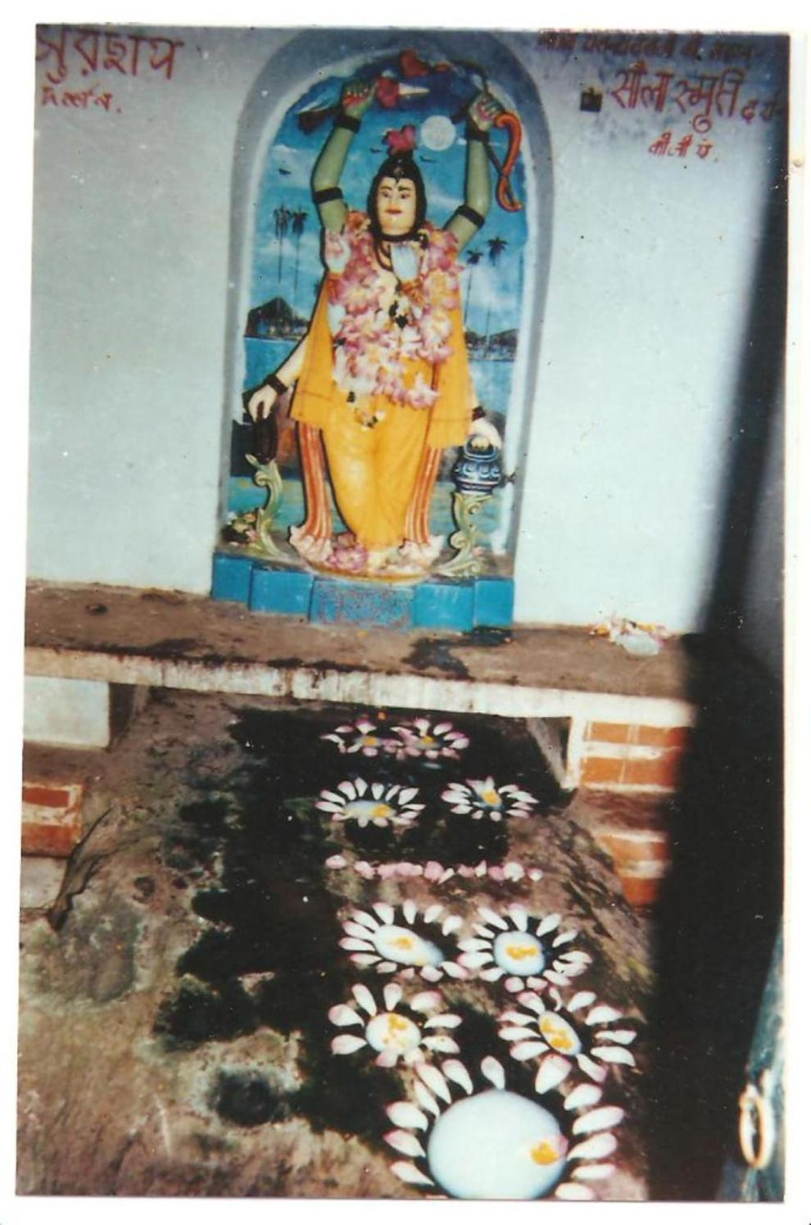

Molten rock at Âlâlnâth

*Sri Sri Gour-vidhur-jayati*
Sri Sri Gândharvikâ-Giridhârou jayatah

HARE KRISHNA HARE KRISHNA KRISHNA KRISHNA HARE HARE
HARE RÂM HARE RÂM RÂM RÂM HARE HARE

The first English Râgânugâ magazine

YEAR 1 : Issue no. 05

Sri Gourângâbda 522 Month: Vâman 16 Jun’07–17 Jul ‘07

Sa jeeyât Krishna-chaitanyah Sri-rathâgre nanarta yah,
Yenaseej-jagatân chitran jagan-nâtho’pi vismitah.

“All glory to Sri Krishna-Chaitanya Mahâprabhu Who danced before the beautiful chariot of Sri Jagannâthji and when the people saw His dance they were definitely astonished, however the remarkable fact is that even Lord Jagannâth Himself was astounded.” - (Sri Chaitanya-Charitâmrita 2.13.1)

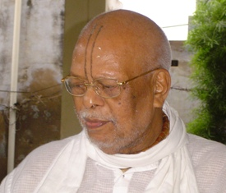
Chief Editor of Guidance in Love:

108 Sri Srimat Ananta das Babaji Maharaj, Pandit and Mahant of Radhakund.

In this issue
Cover Photo – Darshan of Lord Jagannâth remains closed after Snân-yâtrâ (bathing ceremony). The devotees get Their Lordships’ darshan directly during the Rath-yâtrâ. When Sriman-Mahâprabhu did not get Sri Jagannâthji’s darshan, he was so full of viraha that He went to Âlâlnâth, to take darshan of the Lord since Lord Âlâlnâth is non-different from Lord Jagannâth. When He reached there, He threw Himself down on the rock in front of the gate of Âlâlnâth. His body was burning so much in separation that the rock melted wherever His body touched it. We can see the pits in the rock, namely, at the head, hands, knees, feet etc. Later on, the priests removed the rock and placed it in a special place. The devotees worship it daily by filling the pits with milk and flowers. In the background, we also see the six-handed form of Sriman-Mahaprabhu that he displayed to Sârvabhouma Bhattâchârya, whose house is close to the Âlâlnâth Mandir.

Please SELECT the topic you want and press Ctrl and Click. You will go to the topic of your choice.

- Holy Invocation – Our Shâstras contain many prayers that express love for Ishtadev. In this issue, we present a prayer from Sri Chaitanya Charitâmrita.

- Sri Sri Nityânanda-ashtakam – Sevâ-aparâdhs are another barricade in Bhakti. All the saints and Shastras state that the only way to get rid of sevâ-aparâdhs is to sing various glorifications. (Of course, we must also beg forgiveness from Our Lordships.) Which are the Râgânugâ hymns that we must sing daily? The minimum requirements are the glorifications of–
  - Sri Vaishnav
  - Sri Gurudev
  - Sri Goursundar
  - Sri Nityânanda Prabhu
  - Sri Advaita Prabhu
  - Sri Govinda
  - Sri Râdhârâni
In this issue, we present ‘Glorification of Sri Nityânanda Prabhu’ by Srila Krishnadâs Kavirâj Goswâmi. The Bhajanânandi Vaishnavs in Radhakund recite some prayer-songs (popularly known as ‘ashtakams’) daily on a compulsory basis. We must try to memorize these hymns so that it is easier for us to recite them anywhere and everywhere.

- With love from the Editor – Babaji Maharaj’s message for spiritual seekers.

- Our sweet Lord of Love - Sri Gourhari - Glimpse into the life of our Beloved Sri Gourânga Mahaprabhu, the Love Incarnate.

- Leelâ-smaran (Purvânha-leelâ) – Mahâjan Poems
  - Pournamâsi Devi questions………… by Shekhar Roy
  - ……………and Vishâkhâ replies by Mâdhab dâs

- Goursundar’s beloved Deity – Sri Jagannâthdev –
Snân-Yâtra (the Grand Bathing Ceremony)

- Love-feasts at a glance – Your monthly Almanac
- News from Râdhâkund by our special correspondents Râdhikâ dâsi and Sâdhanâ Dâsi

Go to index

An ode to Lord Nityananda

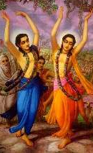

By

Srila Krishnadâs Kavirâj Goswâmi
Part 2
Abani-mandala, preme-badala, korolo abadhouta dhâbitang
Tâpi deena-heena, târkika durjana, keho nâ bhelo banchitam.
Sripada-pallaba, madhura mâdhuri, bhakata bhramara sukha peetang
Jayati jaya, basu jâhnabâ-priyo, dehi me swa-padântikam.5.

Abani-mandala – the sky; preme-badala – clouds of love; korolo – did; abadhouta – cleanse very much; dhâbitang – to run; Tâpi - suffering; deena-heena – poor and miserable; târkika - the argumentative; durjana – evil people; keho nâ bhelo banchitam – no one was left out; Sripada-pallaba - soft and beautiful lotus feet, where Laxmi Devi resides; madhura mâdhuri – sweet sweetness (very sweet) bhakata - devotees; bhramara – bumble bee; sukha - joyously; peetang - drink; Jayati jaya – all glory; basu jâhnabâ-priyo – Beloved of Mother Vasudhâ and Jâhnabâ; dehi - please give; me - me; swa-padântikam – Your lotus feet.5.

Go to index

Meaning – “You appeared as Avadhut and covered the sky with clouds of love. Thus, You cleansed the earth of all the sins with torrential showers of love. You delivered all those who were suffering and left out none – whether he may be a doubtful person who argues with You or someone who is evil. Your lotus feet are so soft and beautiful; they are so very sweet that Your devotees drink the nectar from them happily, as bumblebees drink honey from the lotus. O Beloved of Mother Vasudhâ and Jâhnabâ, all glory unto You! Please grant me shelter at Your lotus feet”. 5.

O manimanjeera charu-taralito, madhura madhura sunâditang
Atula râtula, jugala padatala, amala-kamala-surâjitam,
Tejiyâ amara, abani himkara, nitâi pada-nakha-shobhitang
Jayati jaya, basu jâhnabâ-priyo, dehi me swa-padântikam.6.

O – That; manimanjeera – gem-studded anklets; charu-taralito – finely shaped; madhura madhura - very sweetly; sunâditang - sound; Atula - incomparable; râtula – rosy; jugala padatala – soles of the two feet; amala-kamala-surâjitam – reigning supreme like pure lotus; Tejiyâ –discarding; amara-abani – the sky; himkara - - moon; nitâi pada-nakha-shobhitang – has taken shelter of the beautiful toe-nails of Lord Nityânanda; Jayati jaya – all glory; basu jâhnabâ-priyo – Beloved of Mother Vasudhâ and Jâhnabâ; dehi - please give; me - me; swa-padântikam – Your lotus feet.6.

Meaning – “How sweetly Your gem-studded anklets chime on Your beautiful feet! The soles of Your feet are so indescribably rosy and they reign supreme (spread fragrance all around) like pure lotus! The moon discards the heavens and takes shelter (thus the moon beautifies himself) of Your lotus feet. O Beloved of Mother Vasudhâ and Jâhnabâ, all glory unto You! Please grant me shelter at Your lotus feet”. 6.

Go to index

(to be continued)

My dear devotees,

Râdhe Râdhe.

Almost one and half month ago, we celebrated ‘dhoolot’ or the ‘dust-feast’ on Mâ Jâhnavâ’s appearance Day. What is so special about the dust of Sri Vrajadhâm? Why does everyone consider the earth of Vraja as divine? Well one reason is that she displays the nineteen symbols under Sri Krishna’s feet proudly on her bosom. Wherever Sri Krishna sports, the earth there holds on to His footprints along with their nineteen symbols. Vraja-bhumi (the earth of Vraja) never lets go of these footprints. This is evident from the fact that when Sri Krishna had sent Sri Uddhav from Mathura to Vraja, in order to console the Vrajavâsis, Sri Uddhav came to Nanda Maharaj’s house and on seeing their pangs of separation and heart-rending tales of sorrow; he consoled him by saying – “O King! You are always sitting at home and thinking about Krishna. So You are feeling sad. If You step out and see the beauty of the woods, mountains, rivers, etc. You will feel better”. On hearing this, Sri Nanda Maharaj replied-

“O Uddhav! I have tried that also. However, as long as I am in Vrindâvan, there is no way I can forget Kanhaiyâ. Every part of Vraja, be it Yamuna, Mânas-gangâ or Govardhan, is decorated with the footprints of my Krishna. Dear Uddhav! There is no place in Vrindâvan where my Krishna has not performed His pastimes. Wherever I go, I see His extraordinary footprints. Then the fire in my heart is rekindled a hundred times more”.
- [S.B. 10.46.22]

It is evident from King Nanda’s words that Vrajabhumi always holds Sri Krishna’s footprints close to her heart. It is in this manner that Vrindâvan spreads the glory of Earth everywhere right up to Vaikuntha. Hence, we see in Venu-geet –

“Dear sakhi! Sri Vrindâvan is spreading the glory of Earth in the entire universe. This is because Sri Krishna’s beautiful footprints are seen everywhere in Vrindâvan”.
- [Vrajadevis in S.B.10.21.10]

But Sri Vrindâvan is divine. He is not connected with Earth at all. He is Vibhu (almighty). He is present everywhere – above in Golok and as well on Earth. So You may ask why should Earth consider herself fortunate if Sri Krishna’s footprints are present in Sri Vrindâvan? You are right. But Earth feels glorified because Vrindâvan has taken mercy on her and is residing on her bosom.

The beautiful footprints of Sri Krishna with their nineteen symbols are not present anywhere else in the universe, be it Heaven or even in Vaikuntha. It is very rare to come across some earth that has been in contact with Sri Krishna’s holy feet.

We find in Srimad-Bhâgavatam, “The Yogis who have attained total self-control and have performed austerities for many lifetimes are not able to attain even a speck of the dust of the Lord’s lotus feet. But the Vrajavâsis are so fortunate that Swayam Bhagavân Sri Krishna is present right in front of their eyes. How can I express their good fortune?”
- [S. B. 10.12.12]

To reside in Sri Vrajadhâm and perform Bhajan following in the footsteps of the Vrajavâsis should be the highest goal for any devotee. All glory to the devotees who are following Sriman-Mahâprabhu’s instructions and they have accepted the position of Srimati Râdhârâni’s maidservant (the topmost status in the spiritual world)! This Bhajan in Manjari-swarup becomes more intense and perfect when we reside in Sri Vrajadhâm. Therefore, we should strive for the same.

Wish you all the best in your Bhajan. Jay Sri Râdhe!
Your servant

Ananta das.


Go to Index

The life and teachings of Sri Gourânga Mahâprabhu - the Love Incarnate

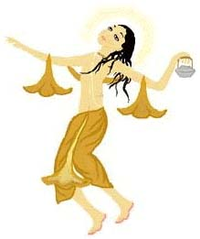
Bujhe ba nâ bujhe ho, shunite shunite seho,
ki adbhut Chaitanya charit,
Krishne upajibe preeti, jânibe raser reeti,
Shunilei hoy boro hit.

“Sri Chaitanya Mahâprabhu’s life is so wonderful that if we hear constantly although we may not understand anything, we shall gain love for Krishna and learn the doctrine of rasa. It behooves good even if we simply hear it.” - (C.C.2.2.76)

[A compilation of Sri Chaitanya Bhâgabat by Vyâs-avatâr Sri Vrindâvan dâs Thâkur, Sri Chaitanya Charitâmrita by Srila Krishna dâs Kavirâj Goswâmi, Sri Chaitanya Mangal by Sri Lochan dâs Thâkur, Sri Bhakti-Ratnâkar by Sri Narahari Sarkâr Thâkur and Sri Swarup-Dâmodarer Korchâ by Sri Swarup-Dâmodar.]

Part 5

Child Nimâi imparts the supreme philosophy

Shachi Mâtâ was assured that her Nimâi had become a good boy now that they had performed the fire-sacrifice and propitiated all the Devatâs. She took Him for a bath in the Gangâ. As she walked, Gourânga ran in front of her and went right where people dumped garbage. Mother Shachi could not bear it. She shouted at him – “Nimâi, come here immediately”. But who wanted to pay any heed to her? Gourachandra cared the least for her commands. He continued to play pranks all the while.

Dekhiyâ janâni debi kore hây hay
Adhik chanchal putra hoilo âmây
Swastayaner dharma âro hoilo bistâr

“When Mother saw the waywardness of her child she lamented - the fire-sacrifice and the pujâs have made my son all the naughtier.”

Shachi Mâtâ forbade Him to touch anything that was impure. However, the Lord explained,

Ki shuchi ashuchi kiba dharmârdharma Tattva
Nâ bujhi bichâr kichhu moroye jagat
Khiti jol bâyu agni âkâsh âkâr
Jagate jatek ihâ boi nâhi âr.
Shri-krishna-charan boi nâhi anya dharma,
Tâ binu sakal michha kohilo ei mormo

“Dear mother, what is pure and what is impure? Nobody understands what is right and what is wrong. People spend all their life trying to ascertain the Truth yet they cannot arrive at the right conclusion. Everything in the universe is made of ether, water, air, fire and sky. They only differ in their shapes. And there is no right path other than to surrender at Sri Krishna’s lotus feet. Everything else is false. I tell you, this is the philosophy in a nutshell.”

Shachi Mâtâ was immensely surprised. She told Jagannâth Mishra “bâlak caritra kichhu shuno mahâshay, sarba jagnamoy ei tomâr tanay” – “Sir, there was no need to perform any fire-sacrifice for your son, because He is the source of all yagnas.”

Nimâi and the puppy

What Lochan dâs describes next is remarkable. One day as Nimâi was playing with His friends, all of a sudden there arrived three or four puppies. The boys were overjoyed. Gourhari chose one them and picked him up on his lap. This annoyed the other children. They puffed their cheeks and said, “shuni shuno bishwambhar, kutsit chârile, bhâlo tumi nile, nâ khelibo jâbo ghar” - listen Vishwambhar, you picked the best of them and left the ugly ones for us. We shall not play with you any more, we shall return home.” But the compassionate Lord assured them, “ei chânâ sobâkâr, sobei miliyâ khelo ihâ loiyâ, thâkibe ghore âmâr” – do not worry, this puppy belongs to all of us. We shall all play with him. But he will stay in my house.

Nimâi took the puppy home and tied it to a chair. Shachi Mâtâ had gone to the Gangâ for bathing when all this happened. Vishwambhar was most happy to find his mother gone and the house empty. He called all the neighboring kids and they gathered around the puppy. They cuddled it and kissed it. The puppy was ecstatic when Lord Gouranga touched it. It rolled in the dust and the Lord too rolled after it. The children were covered with dust from head to toe. You would hardly recognize them! Then two boys started fighting over the pup. Each wanted to hold it. They started a tug-of-war holding the poor puppy in between. How could compassionate Nimâi bear to see His devotee suffer? He spoke up -
“niti niti âsi koloho koris, kemon swabhâb tor?
Heno bujhi tor charit âchâr, shwaner shâbak chor.”

“You fight every time you come here, what sort of a boy are you? (He told one of them) I think you want to steal my puppy.”

Now this landed Him in trouble, for that boy immediately ran to Mother Shachi and complained –

Shuno shuno âre tor bishwambhare
Shwâner shâbak loiyâ
Khone kole kore khone gole dhore
Âpone dekhonâ âsiyâ

“Listen O Mâtâji, your darling Vishwambhar has brought a puppy home. He sometimes takes it in His lap and sometimes embraces it. If you don’t believe me, go and see for yourself.”

Shachi Mâtâ was appalled when she heard this. She hurried back from the Gangâ as soon as she could. When she entered the house, she was shocked to see “shwâner shâbake bishwambhar kole kore” – Vishwambhar, the apple of her eyes, holding a puppy in his arms. She slapped her head and screamed, “nâ jâni ki tor leelâ, sakal thâkite ati bipartite kukkur chha loiyâ khelâ” – Nimâi, I really cannot understand your leelâs; you have all sorts of toys, why can’t you play with them? Must you play with a baby dog, of all the things?” She continued with –

Janak tohâri ati dharmachâri
Tâhâr tanay tumi,
Ki bolobe loke shwâner shâbake
Khelâo ki sukh mâni
“Your father is so righteous and you, being his son engage in such dirty games! What will the people say when they come to know that you are playing with a puppy?”

“Oh Nimâi, you have put a spear through my heart! (e shel hridoye mor). And look at you! How you have covered your beautiful body with dirt! You have completely spoilt your moon-like face and sweet body that dazzles like lightning! (koto chând jinni tor mukh khâni, ki thir bijuri anga). You are always playing with bad boys.” Shachi Devi was red in anger and bit her lips. Then she pointed a finger at Him and ordered –

Nija ghore jâo kukkur châ lao
mâ bâpere deho dâli
“Take the puppy and return it to its parents.” Then as she gazed at His lovely face and He looked so miserable that she was overcome with love. Her voice softened and she spoke lovingly to Him, “Come here my darling, come into my lap. Here, let me kiss you. Leave that puppy and go bathe in the Ganga. Are you not hungry? It is already 2 O’clock. How you make me suffer! Tie up that puppy, alright? Play with it in the evening. Now go to the Ganga, bathe and eat something.”

Little Vishwambhar laughed. Aha! Mother had relented at last! He put His soft arms around Mother Shachi and said, “Yes, mother, I shall go to bathe.” Mother brushed the dust from His body with utmost love and massaged Him with fragrant oil. The Lord went to the river with all His friends and started sporting in the water. The boys pealed with laughter while little Nimâi showed them all sorts of tricks He could perform in the water.

Here, at home, what did Mother Shachi do? As soon as Nimâi left the home, she immediately untied the puppy and left him outside the house. A little distance away it spotted its mother and went away with her. A naughty boy saw this. He went running to the banks of the Gangâ and shouted, “shuno Bishwambhar, janani tor, kukkur châ edi dile”- Hear O Vishwambhar! Your mother has left the puppy.

It appeared as if the sky had fallen on little Nimâi. He ran helter-skelter towards His home.

What will Nimâi do now? Will He get His puppy back? To know more please read the next issue of Guidance– in–love.

(to be continued)



Go to index

Purvânha-leelâ

Vrindâvan-meditation

Râdhârâni wakes up

(Devi Pournamâsi questions Sri Râdhâ)

By

Shekhar Roy

Âju biparoto dhani dekhalun toy,
Samajhi na pâriye samshay moy.

“I see some contrary effects on you today, please clear my doubt. ”

Tuwâ mukha mandala punamiko chând,
Kâhe lâgi bhoi gelo aichhana chhand.
Noyono-juale bhelo kâjara bithâr,
Adhara niras koru kon gonwâr.

“Your face is like the full moon, yet why does it look like this today? It has turned black with the kohl spreading from your eyes and your lips are dried up.”

Peen-payodhare nakha rekh delo,
Kanaka-kumbha janu bhaganahi bhelo.
Ange bilepana kumkuma-bhâr,
Peetâmbara dhoru ithe ki bichâr?

“I can see nail-marks on your bosom and your golden breasts seem to have broken. There are marks of kumkum all over your body and you are wearing an yellow robe. What is all this?”

Sujana ramani tuhu kulâti-bâd,
Kâ sane bhujnali moromoko sâdh?
Kâmini-kâhini debi sambâd,
Koho kabi shekhara noho paramâd.

“You are supposed to be a decent girl. With whom have you satisfied your heart’s desire?” Devi Pournamâsi was curious to know about Srimati’s pastimes. Poet Shekhar says, “Do not worry”.

(Vishâkhâ replies)

Shuniyâ bishâkhâ kohe bâni,
Ki dekhi ki koho thâkurâni?

“When Vishâkhâ heard this, she said – Thâkurâni (Madam), what are you seeing and what are you saying?”

Sakhi mor kula baratini,
Nijo pati bine nâhi jâni.
Kâli kuhu barati sakale,
Tâhe dillo haladiro jale.
Tei peeta hoilo basan,
Tuhu tâhe kâhe âno mon?

“My friend is the most decent of all the women in Vraja. She knows no one other than her own husband. However, yesterday we had dipped her robe in turmeric water, this is how it turned yellow. Why must you think otherwise?”

Baraja-lampata shath keere,
Bimbu-bhâne dansala adhare.
Puno se dârim bhân kori
Pada nakhe hridoy bidâri.

“A mischievous parrot of Vraja, who is also a cheat, bit on her lips mistaking them as berries. The same parrot also wounded her bosom with its claws taking them to be pomegranates.’

Tuhu sob antarjâmini
Jâni kâhe koho heno bâni
Eto kohi paranâm kelo
Shuni hâsi bhagabati gelo.

“You are all knowing. When you already know everything, why do you ask? Saying this, Vishâkhâ paid obeisance to Sri Pournamâsi devi. Bhagavati laughed and walked away.”

Mâdhaba ânanda bhelo,
Peeta basana tahin nelo.

“Poet Mâdhâb dâs felt very happy when he witnessed this swet pastime and he (in his manjari-swarup) took away the yellow robe.”

Go to index

Goursundar’s beloved Deity

Part 4

The Grand Bath (Saturday, 30th June ‘07)

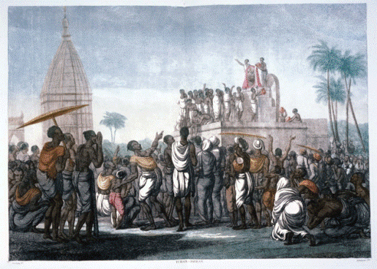

Nearly all of us are familiar with Lord Jagannâth’s Ratha Yâtrâ. However we do not know much about His Grand Bathing ceremony or ‘Snân-Yâtrâ’ – the more popular name for this sweet ritual. This is ht Annual Bathing Day for Their Lordships – Sri Jagannâth Dev, Sri Balarâm and Devi Subhadrâ.

On this occasion the whole city of Puri gains a different look. Pitchers of water are poured on the Deities. The water runs down Their divine bodies and floods the entire place, yet the bath does not stop. Naturally, They fall sick after this grand endeavor. My dear devotees, of course you have the right to ask “How come Almighty God falls ill?” Well, this ‘getting fever’ is also a leelâ of Sri Krishna to glorify our dear Ishwari.

When Sri Krishna heard that the Vrajavâsis were defaming Srimati Râdhârâni by calling Her ‘unchaste’ He felt very sad. He returned home and lay down. He got a fever. Mother Yashodâ touched Him and realized that Her son’s body was burning with fever. She immediately sent for Nanda Mahârâj. He called one doctor after another, yet the fever refused to come down. Ultimately the doctors called a conference. They decided that Nanda Mahârâj should send for some big doctor from outside Vraja. Sri Krishna snatched this opportunity. He disguised Himself as an old doctor. He told Mother Yashodâ, “Mâtâji, this is not a common fever. If some pious and chaste woman can bring water from the Yamunâ in a vessel having a hundred holes, before sunrise with her eyes closed, and bathes your son with it, then this fever will disappear.”

Mother Yashodâ and Nanda Mahârâj announced the news to the Vrajavâsis. However, the women who had been talking the most against our dear Swâmini failed to fulfill the task. At last, Srimati Râdhârâni discarded all fear and shame. She stepped forward for the sake of the Beloved of Her heart and with a heart full of the most brilliant and pure prem, She brought water from the Yamunâ in a vessel with a hundred holes. She bathed Sri Krishna with this water. After the Snân (bath) people were most astonished to see that the fever had indeed disappeared. The Vrajavâsis (especially Jatilâ and Kutilâ) were forced to accept that Srimati Râdhârâni was the chastest of them all. Otherwise how come Sri Krishna recovered from the illness? Srimati’s prem is present in the Gold Well of Sri Jagannâth Mandir in the form of water.

During Snân-yâtrâ the Deities move from the altar to the bathing-altar. This movement is called ‘pâhandi’. The sevaks fan Jagannâth, Balabhadra and Subhadrâ with fly-whisk and palm leaf fans during pâhandi. Their bodies are covered with beautiful silk cloth.

Jagannâth Dev had ordered King Indradyumna that no one should take His darshan for fifteen days after the Snân-yâtrâ. Therefore the Mandir remains closed for these fifteen days. We call this time period as ‘anasar-kâl’. From Snân-purnimâ to Ubhâ-Amâvasyâ (this year 30th June to 14th july). He spends this fortnight in one room called ‘nirodhan griha’ which is right beside the sanctum sanctorum of the Jagannâth Mandir.

What does Lord Jagannâth do in the Nirodhan Griha for full fifteen days? The priests explain to the devotees who are eager for darshan, that the Lord is ill due to ‘too much bath’. Now we are feeding Him some medicine-bhog. Of course, the devotees get the ‘medicine-prasâdam’ as well. So we have nothing to worry. What does this ‘medicine-bhog’ comprise? It is nothing but an Ayurvedic tonic. The private physician of the royal family prepares a special nutritious ‘sweet’. Then he makes a sherbet of cream and sugar candy. A glass of green-coconut water mixed with a dash of camphor is also offered. Then the Lord accepts a medicinal dish called ‘sâbu’ – sago in milk, with bay leaves and cardamom. The priests very carefully prepare another medicine called ‘bakkâl’. They judiciously grind neem leaves, haritaki, nutmeg (jâiphal), kâlmegh (a very bitter leaf), ginger, honey, cinnamon, black pepper, siddhi leaves and camphor. They then dissolve it in pure cow milk and Gangâ water. The Lord takes this along with green-coconut water. There are some three or four families of doctors who serve Lord Jagannâth during this time. They are indeed blessed. They treat the Lord of the universe Whose very Name cures us off all material diseases!

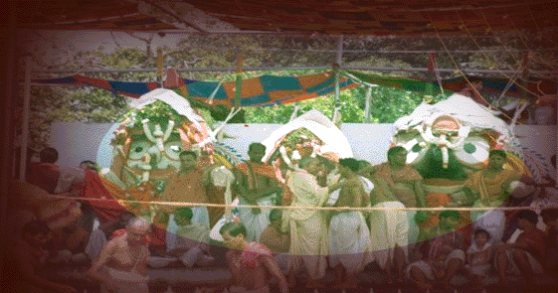

On Snân-Yâtrâ the Bhog comprises of many items. Only on this day the devotees can behold the Bhog offering since it takes place in front of the public. Let us learn the names and process of preparing some of these dishes.

- Suvâs-pakhâl – Boil rice. Drain the water. Wash it in cold water. Before you do this, you should soak some roses, mallikâ, bel and jasmine in water fro two hours. Sieve this water through a clesn cloth and mix this water with the rice. Add salt to taste. Offer Lord Jagannâth with a soup of raw plantain, brinjal, potol, ghee and the simple spices.
- Pita – It is a slightly bitter bhog. Cube plantain flower, plantain stem, egg-plant, potato, sweet potato, sweet gourd. Add shredded coconut to the vegetables. Roast fenugreek, cumin, black pepper and coriander and powder them. Boil all the ingredients together. Add a seasoning of cumin in ghee.
- Tipuri – Take the bark of Garud-govinda tree (you’ll get this only in Puri). Dry it in the sun. Powder and sive it. Then mix it with water and powder rice. Make a batter as thick as cake batter. Heat ghee in a pan. Pour one spoon of batter at a time and fry it. Then dip in thick sugar syrup.
- Shâk – (leafy vegetable) – Lord jgannâth’s Bhog is never complete without leafy vegetable. It is a compulsory Bhog and Laxmi devi is supposed to prepare it herself. The Oriyâs call it ‘neutiyâ’. Boil ht eleaves with salt and ghee. Then heat ghee in a pan. Add cumin and asafetida to it. Put the boiled leafy vegetable in it and mix nicely.

In this manner many more transcendental bhog items are offered to Lord Jagannâth on Snân-Yâtra. We name a few of them – phuri-shuktâ, kokhâru-santora, green beans khichri, cream sweet, rice and jaggery roti, blach bean-ladoo, condensed milk laddoo, cream-petals etc.

After the Grand Bath the Deities are dressed in Ganesh Vesh.

What does Lord Jagannâth do all the while, locked up in the Nirodhan Griha for one whole fortnight ? Does He not get bored without His devotees? Well, plenty happens during these fifteen days in the Nirodhan Griha, which is a ‘secret’. But we would like to divulge this ‘secret’ to you, since you are our beloved readers……….in the next issue of Guidance-in-Love.

(to be continued)



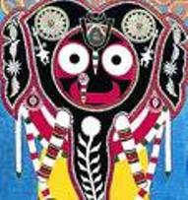    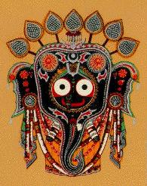
Go to index

(16 Jun -17 Jul)

N.B. - We fast from one sunrise to the next and must always break fast after sunrise. For eclipse, please refer your regional calendar.

Date | Day | Phase of the moon | Love-feast
16 Jun | Sat | 1st | -
17 Jun | Sun | 2nd and 3rd | Grand Feast in honor of Sri Gopâldâs Bâbâ’s Disappearance Day, Radhakund
18 Jun | Mon | 4th | -
19 Jun | Tue | 5th | -
20 Jun | Wed | 6th | -
21 Jun | Thu | 6th | -
22 Jun | Fri | 7th | Grand Feast in honor of Sri Sanâtan Bâbâ’s Disappearance Day, Govardhan
23 Jun | Sat | 8th | Grand Feast in honor of Sri Jagannâth dâs Bâbâ’s Disappearance Day, Puchhri gofâ.
24 Jun | Sun | 9th | -
25 Jun | Mon | 10th | Sri Gangâ-Dashaharâ, Appearance Day of Sri Gangâ Mâtâ Goswâmini, Grand Feast in honor of Sri Baladev Vidyâbhushan’s Disappearance Day, Shyâmsundar Mandir, Vrindâvan
26 Jun | Tue | 11th | Nirjalâ Ekâdashi  (Fast)
27 Jun | Wed | 12th | Break fast before 9:25AM, Grand Feasts in honor of Sri Adharchand Goswâmi (Vrindâvan), Sri Satyaharidâs Bâbâ (Jatipurâ) and Pandit Sri Vrajasundar dâs Bâbâ (Gour dhâm Colony, Radhakund) ‘s Disappearance Day
28 Jun | Thu | 13th | Srila Raghunâth dâs Goswâmi’s Danda Mahotsav, Radhakund and Grand Feast in honor of Sri Jay Krishna dâs Bâbâ’s Disappearance Day (Govind kund, Ânor)
29 Jun | Fri | 14th | -
30 Jun | Sat | Full Moon(Purnimâ) | Sri Jagannâth dev’s Snân-yâtrâ
1 Jul | Sun | 1st | Grand Feast in honor of Srila Shyâmânanda Prabhu’s Disappearance Day
2 Jul | Mon | 2nd | -
3 Jul | Tue | 3rd | Grand Feast in honor of Siddha Srila Nityânanda dâs Bâbâ (Madanmohan Thor, Vrindâvan0, Prabhu Sri Prângopâl Goswâmi (Nabadweep) and Prabhu Srila Devakinandan Goswâmi’s (Vrindâvan) Disappearance Day
4 Jul | Wed | 4th | Grand Feast in honor of Sri Gourhari dâs Baba’s Disappearance Day (Radhakund)
5 Jul | Thu | 5th | Grand Feast in honor of Sri Mukunda dâs Baba’s Disappearance Day (Radhakund)
6 Jul | Fri | 6th | -
7 Jul | Sat | 7th | -
8 Jul | Sun | 8th | Sri Sriman-Mahâprabhu’s departure for Âlâlnâth, Puri.
9 Jul | Mon | 9th and 10th | Grand Feast in honor of Sri Mahant Sri Manohar dâs Bâbâ’s (Govardhan) Disappearance Day
10 Jul | Tue | 11th | Sri Yogini Ekâdashi (viddhâ) No Fast
11 Jul | Wed | 12th | Fast
12 Jul | Thu | 13th | Break fast before 9:29 AM.
13 Jul | Fri | 14th | Sri Odiyâ-Goudiyâ meeting (Puri)
14 Jul | Sat | New Moon (Amâvasyâ) | Sri Râghav Pandit’s Prasâdam-basket reaches Sri Gour-Gambhirâ, Puri
15 Jul | Sun | 1st | Cleaning of Sri Gundichâ, darshan of the New Youth of Sri Jagannâthdev, Netrotsav, Puri. Grand Feast in honor of Sri Sakhicharan Dâs Baba’s Disappearance Day, Radhakund.
16 Jul | Mon | 2nd | Sri Sri Jagannâth Dev’s Ratha-Yâtrâ, Grand Feast in honor of Sri Swarup-Dâmodar and Sri Shivânanda Sen’s Disappearance Day
17 Jul | Tue | 3rd | Grand Feast in honor of Sri Mahant Sri Narottam dâs Baba’s (Vrindâvan) Disappearance Day

Go to index

How Râdhâkund celebrated Purushottam

By

Our special correspondents from Radhakund

Râdhikâ dâsi and Sâdhanâ dâsi

10th June,2007.

Radhakund is celebrating Purushottam month like no one else is celebrating anywhere in the world. The temperature has touched a record of 50 degree Celsius (half-century) and Radhakund still goes on. Jay Radhe!  Radhakund is full of joy
and happy with all the Vrajavâsis shouting “Radhe Radhe” and paying full dandavat and doing Parikramâ to her every day as well as people taking bath at both kundas! There is no silence here at Radhakund. Whole night the Parikramâ around Sri Girirâj Mahârâj goes on with shouts of “Râdhe Râdhe” ringing in the air and the sky. Gurudev (Bâbâji Mahârâj, who is the Pandit and Mahant of Sri Radhakund) said so many people are doing full dandavat and Parikramâ, this is why the Vrajavâsis’ bodies are so strong.

So many people are coming for Parikramâ from all over the world and he said it's a flow like a river. Many people start their Parikramâ very early morning and in the evening time as the weather here is really hot. There are many people staying up late keeping their shops open and many other shops with music going on "with loud speakers" and in full volume! Many of the Mandirs have left their doors open for all Vrajavâsis and other devotees who wants to take rest any time of the day.

Our senior gurubhai Keshav dâs Baba has arranged for water-seva on the Parikramâ-path. Our gurubhai Sri Vaishnav pada dâs baba is speaking very sweetly on Sri Chaitanya-Chandroday drama in Sri Brajananda ghera every evening. After his Harikatha the sweet priest of Sri Radha-Damodar Mandir is giving Harikatha. He too is speaking on Sri Chaitanya-Chandroday. If we hear him, we learn the facts of the drama and can understand Vaishnav pada Baba’s Harikatha better.

15th June, 2007

On the last day, there is a shower of rainfall like Radhakund had hardly witnessed before and the month–long heat has tempered down. This shows the glory of Sri Girirâj and how He blesses us. It is all due to the greatness of Parikramâ. In this way, Lord Purushottam blessed all the devotees who had kept vows during the month before He departed. Jay Purushottam! Jay Radhe!

Go to index

A poem or song that contains eight principle verses

